Logo name nav



video

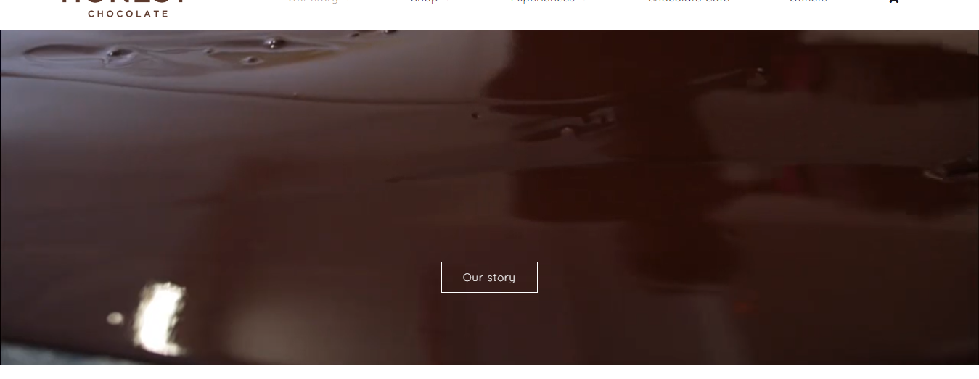

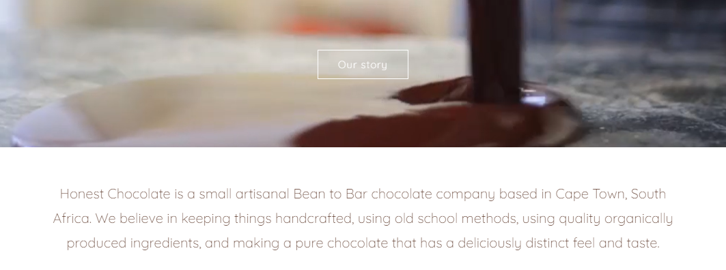

Info

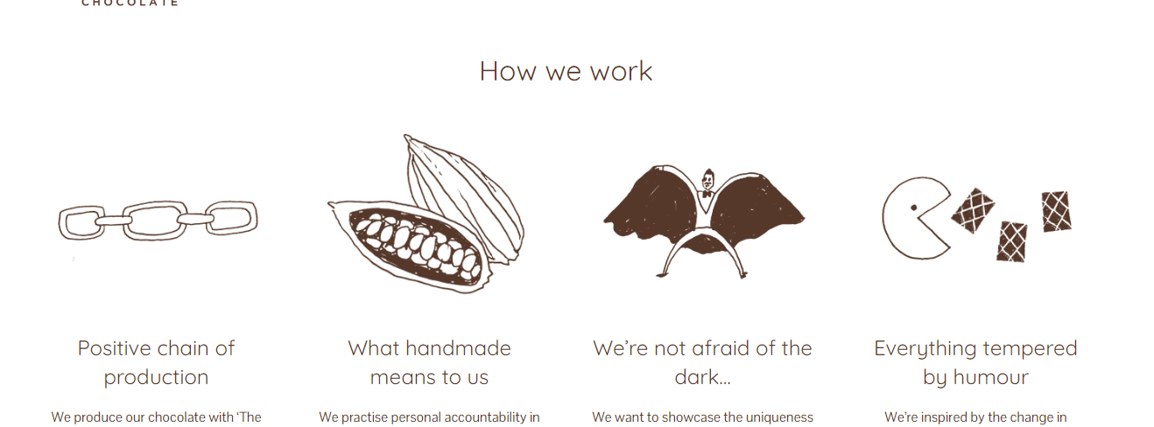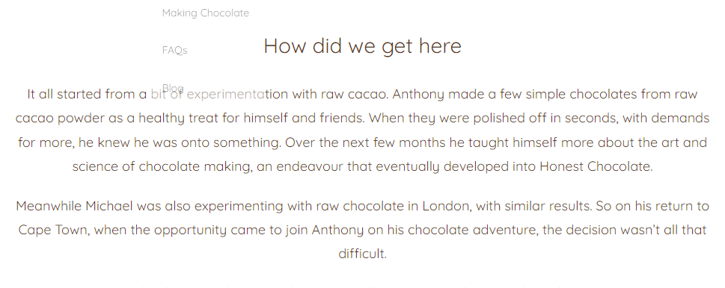

Top selling products

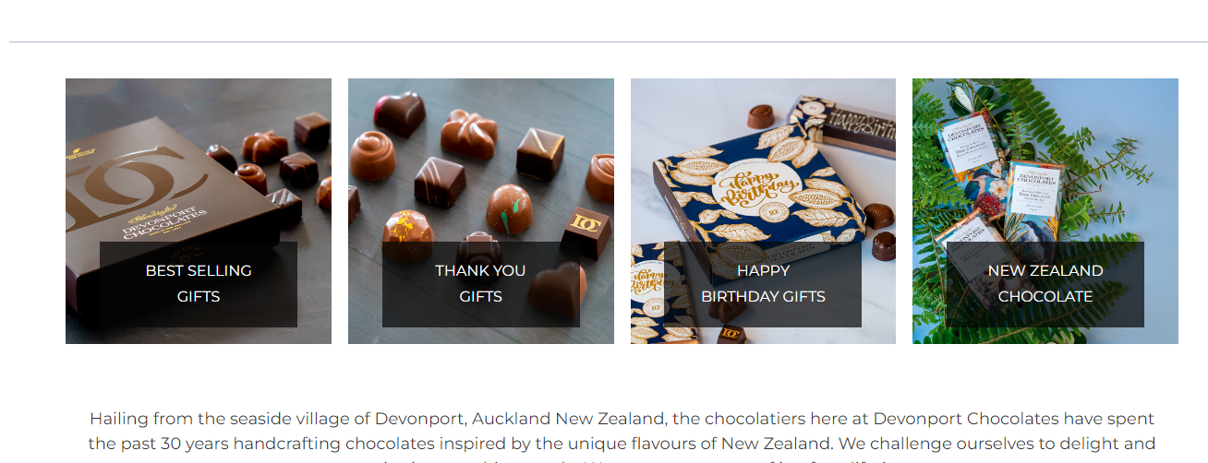

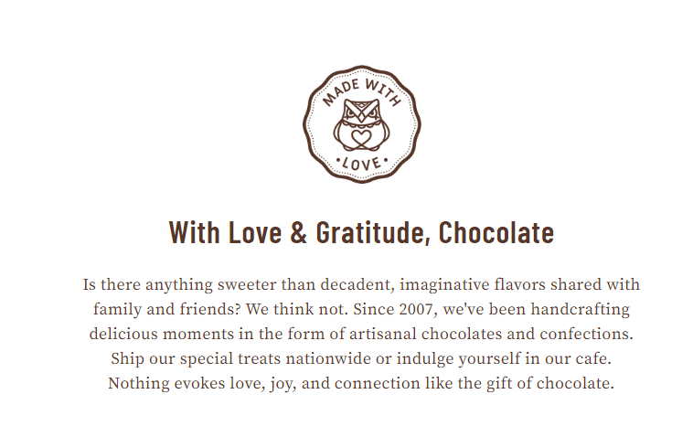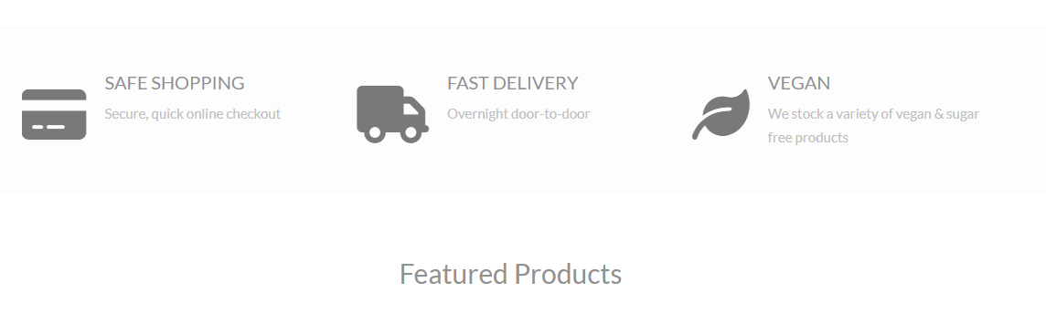

footer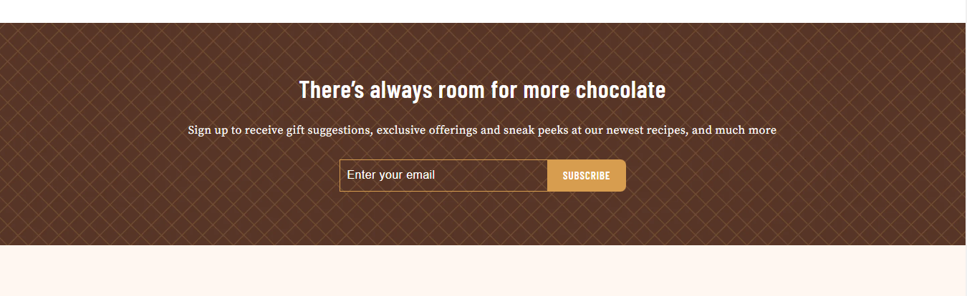

**Our story**

Since 2007, we've been handcrafting delicious chocolate treats, made from ethically and sustainably grown beans.

It all started from a bit of experimentation with raw cacao. We made a few simple chocolates from cacao beans from a variety of local farms. We taught our self-more about the art and science of chocolate making.

We believe in keeping things handcrafted, using old school methods, using quality organically produced ingredients, and making a pure chocolate that has a deliciously distinct feel and taste.

With time we created chocolates with contemporary twists of flavour and design to create exquisite chocolate experiences for you to enjoy.

How we work

All chocolates come beautifully gift boxed, posted by first class delivery service from our shop

We ship our special treats nationwide. All of our chocolate is expertly handmade by our wonderful chocolatiers, then wrapped and packed by hand.

The Chocolate Smiths Subscription Box

A subscription box like no other! Each month you will recieve exclusive chocolately goodies with an exciting theme.

Featured products

Using the best ingredients for our chocolate and lots of delicious ingredients we invite you to try our signature range of Bizarre®chocolate bars made with a heck of a lot of passion.